# Figures and Tables

# Table 1.

Selected soil chemical (0-10 cm depth) and vegetation properties of fertilization treatments at EARTH University forest reserve in Limón, Costa Rica. Treatments consist of control, and nitrogen (+N), phosphorus (+P), and nitrogen and phosphorus (+NP) addition. Different letters denote significant differences across treatment levels, as indicated by Tukey’s h.s.d. The last two columns represent the results of a factorial one-way ANOVA, with F and *p*-values shown. Data from (Vincent et al. *in prep*).

|  |  |  |  |  |  |  |
| --- | --- | --- | --- | --- | --- | --- |
|  | Fertilization | treatment |  |  |  |  |
| Variable | Control | +N | +P | +NP | **F** | ***p*** |
| Soil pHH20 | 4.2 (0.1)a | 4.0 (0.1)b | 4.2 (0.1)a | 4.2 (0.1)a | 5.72 | **0.006** |
| PO4- (μg g-1) a | 3.2 (2.2)a | 3.3 (4.4)a | 45 (32.4)b | 46 (9.7)b | 7.50 | **0.002** |
| NO3- (μg g-1) c | 10.6 (0.6) | 14.5 (1.6) | 9.3 (1.3) | 10.5 (1.8) | 2.18 | 0.126 |
| Total C (g kg-1) | 45.5 (1.83) | 47.0 (2.43) | 45.0 (1.26) | 47.9 (3.30) | 0.47 | 0.706 |
| Total N (g kg-1) | 3.99 (0.20) | 4.07 (0.18) | 3.96 (0.11) | 4.06 (0.25) | 0.24 | 0.869 |
| Total P (g kg-1) a | 1.65 (0.25) a | 1.38 (0.13) | 1.87 (0.20) | 1.94 (0.18) | 0.95 | 0.440 |
| Trees that grew (%)b | 66.3 (4.6) | 66.6 (1.9) | 76.8 (3.7) | 77.0 (3.4) |  |  |
| Litterfall production (Mg ha-1) | 4.61 (0.5) | 4.72 (0.3) | 5.28 (0.8) | 4.43 (0.7) |  |  |

a Extractable in water with anion-exchange resins, and excluding control plot 19 due to anomalously (but presumed natural) high P concentrations.

b Percentage of trees in each plot that had growth 2.7 years after the start of the experiment.

# Table 2.

Effect of fertilization and time as determined by two-way ANOVA (F-values, with p in parentheses) on the mass loss (% of initial mass) of leaf litter and wood, and the nutrient concentration (%), loss (x) and CNP ratios of leaf litter set to decompose for 36 weeks in plots that had received 11 years of +N, +P, +NP or no fertilization at the EARTH Forest Fertilization Experiment in Limón, Costa Rica.

|  |  |  |  |
| --- | --- | --- | --- |
|  | ANOVA result |  |  |
| Variable | Fertilization (F) | Time (T) | F × T interaction |
| Leaf litter mass loss (%) | 0.93 (0.431) | **262 (<0.001)** | 0.75 (0.696) |
| Wood mass loss (%) | 2.30 (0.087) | **197 (<0.001)** | 0.64 (0.804) |
| Litter N concentration (%) | 1.38 (0.256) | **29.7 (<0.001)** | 0.66 (0.581) |
| Litter P concentration (%) | **3.72 (0.015)** | 0.002 (0.967) | 0.003 (0.999) |
| Litter C concentration (%) | 2.22 (<0.094) | **13.406 (<0.001)** | 0.018 (0.997) |
| Litter N content (%) | **3.83 (0.014)** | **46.81 (<0.001)** | 1.00 (0.460) |
| Litter P content (%) | **3.41 (0.023)** | 1.23 (0.307) | 0.470 (0.924) |
| Litter C content (%) | 2.52 (0.067) | **131.0 < 0.001)** | 0.26 (0.339) |
| C/N | 0.25 (0.859) | **53.14 (<0.001)** | 0.45 (0.933) |
| N/P | **5.69 (0.002)** | **3.22 (0.019)** | 0.822 (0.627) |
| C/P | **9.11 (<0.001)** | 1.72 (0.158) | 1.03 (0.439) |

For all variables, degrees of freedom for F = 3, 58; T = 4,58; F × T = 12, 58.

Why is decay constat k not in this analysis? Because it can´t be analysed with a two way anova as there are no “collections”, k integrates the whole decomposition period in one value .

# Figure 1 Location of study sites.

Location of fertilization plots in the EARTH forest reserve in Limon, Costa Rica. There are only four +N fertilization plots because two were destroyed by treefall during a storm.

# Figure 2. Climograph

Average monthly precipitation (blue bars) and air temperature (red line) at EARTH University in Limón, Costa Rica, for 1996−2018. Precipitation data are available for all years from 1996 to 2018, except for 2001, 2010 and 2011, for which precipitation data are missing. Monthly data are available for most years except for 1996 (Jan-April missing), 2000 (Aug missing), 2003 (Aug-Sep), 2006 (Aug-Sep). Air temperature data are missing for the whole of 1997, 1998, 2001, 2010 and 2011. Monthly data are complete for most years except 1996 (Jan-April missing), 1998 (Mar-April), 2000 (Aug and Dec), 2003 (Aug and Dec), 2004 (Sep-Nov), 2006 (Aug-Dec), and 2012 (Nov-Dec missing).

# Figure 3.

Remaining biomass (%) of (A) *Hyeronima alchorneoides* leaf litter and (B) soft woodset to decompose in long-term forest fertilization plots (n=16) at the Earth Forest Fertilization Experiment in Limón, Costa Rica; values shown are means per plot (n=4) ± S.E. Marcelo: Se puede analizar esto con un linear mixed model y ver si las diferencias entre tratamientos se vuelven significativas? Tomando en cuenta las cuatro bolsas en cada parcela (en vez de los means per plot).

|  |
| --- |
| **A** |
|  |
|  |
| **B** |

# Figure 4

Exponentially transformed decomposition constant (*k*), shown as median and 25th and 75th percentiles, for leaf litter and wood that decomposed for 36 weeks and was subjected to four fertilization treatments at the EARTH University forest reserve in , Limón, Costa Rica. Treatment differences were non-significatively different. Values shown are boxplots (median and interquartile range DO THIS JOE STYLE

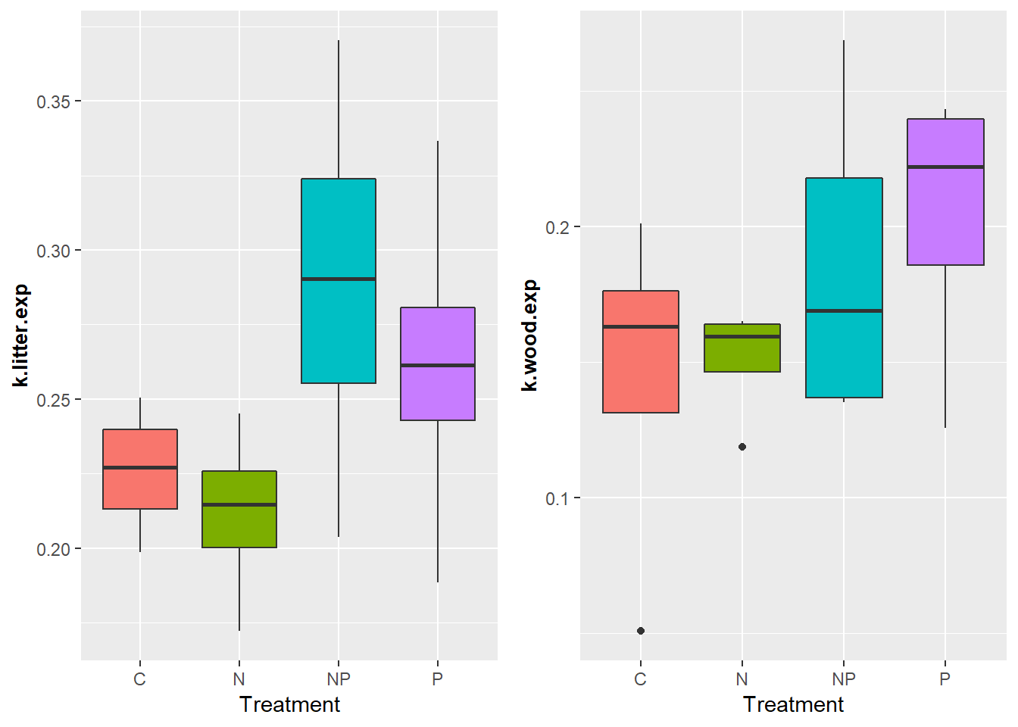

summary(model<-aov(kdat$k.litter.exp~kdat$Treatment))

Df Sum Sq Mean Sq F value Pr(>F)

kdat$Treatment 3 0.01467 0.004891 1.971 0.172

Residuals 12 0.02977 0.002481

summary(model<-aov(kdat$k.wood.exp~kdat$Treatment))

Df Sum Sq Mean Sq F value Pr(>F)

kdat$Treatment 3 0.00947 0.003156 1.081 0.394

Residuals 12 0.03503 0.002919

summary(model<-aov(kdat$k.litter.exp~kdat$Treat.p))

Df Sum Sq Mean Sq F value Pr(>F)

kdat$Treat.p 1 0.01284 0.012839 5.687 0.0318 *

Residuals 14 0.03161 0.002258

---

summary(model<-aov(kdat$k.litter.exp~kdat$Treat.N))

Df Sum Sq Mean Sq F value Pr(>F)

kdat$Treat.N 1 0.00016 0.000156 0.049 0.828

Residuals 14 0.04429 0.003163

summary(model<-aov(kdat$k.wood.exp~kdat$Treat.p))

Df Sum Sq Mean Sq F value Pr(>F)

kdat$Treat.p 1 0.00876 0.008756 3.43 0.0852 .

Residuals 14 0.03574 0.002553

---

Signif. codes: 0 ‘***’ 0.001 ‘**’ 0.01 ‘*’ 0.05 ‘.’ 0.1 ‘ ’ 1

summary(model<-aov(kdat$k.wood.exp~kdat$Treat.N))

Df Sum Sq Mean Sq F value Pr(>F)

kdat$Treat.N 1 0.00013 0.000131 0.041 0.842

Residuals 14 0.04436 0.003169

# Figure 5.

Nutrient content ESTO ESTÁ RARO, QUE TODO SEA POR DEBAJO DE 100% DEL INITIAL VOLVER A CALCULAR ESTO. There were some issues with Silvias/Matteys calculations (just a scalar issue, they hadn’t converted concentrations to percentages), so I corrected this. I also re-did some calculations which turned out to yield exactly the same result, i.e. I (1) added up the mass of all 4 bags collected per plot at each colecta, this is total remaining litter mass per plot per colecta (g), 2) multiplied that by the plot-level % nutrient content, to yield mass of nutrient remaining per plot at each colecta (the justification for doing this is that we measured nutrient concentration on a composite sample of those four bags, not on each individual bag). Results identical. All these are in David-MASTER-datos. **Voy a usar mis cálculos porque el porcentaje se entiende mejor.**

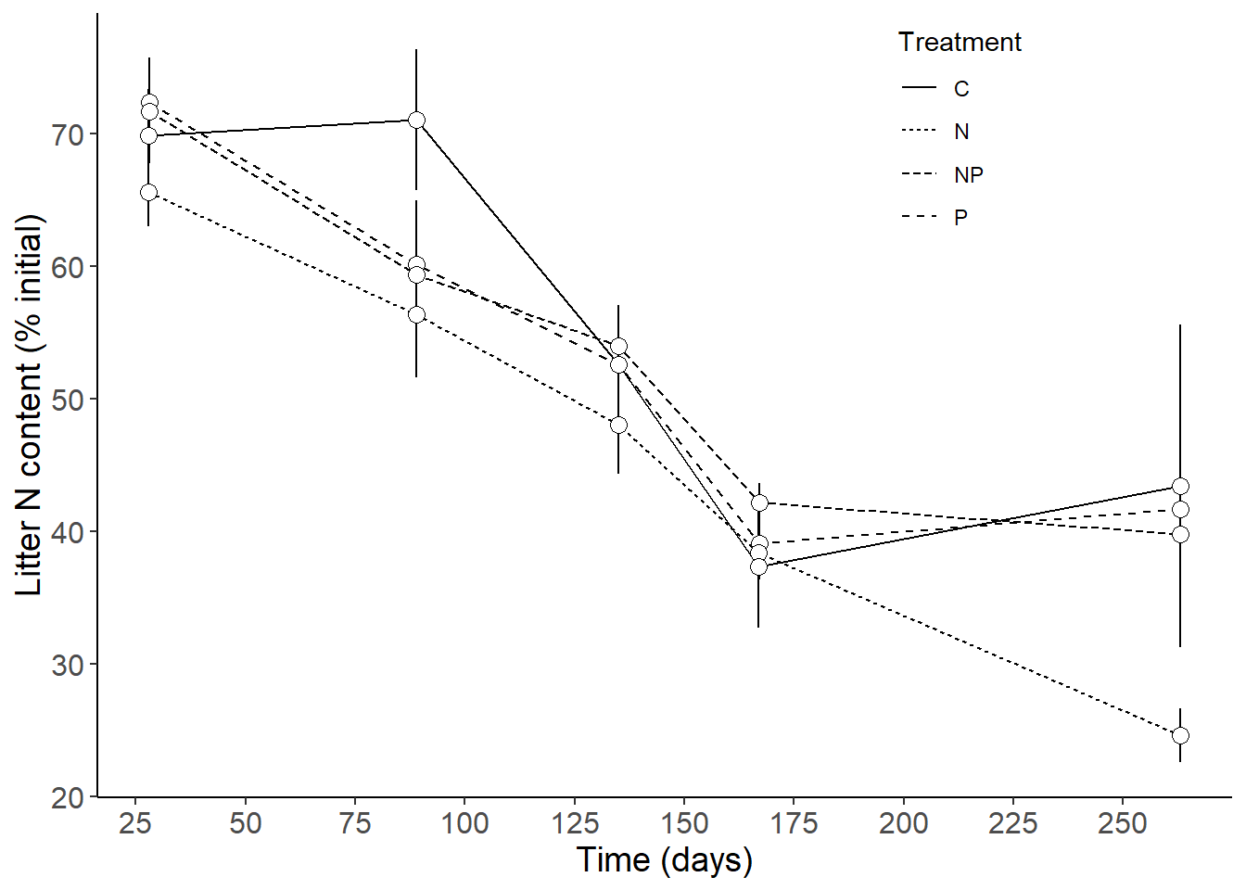

The P data are weird. The super high value is from +P plot 9. None of the other +P plots is that high. RE-GRAPH WITHOUT PLOT 9 AND SEE WHAT HAPPENS. WE NEVER FOUND A VALID EXPLANATION FOR THESE HIGH VALUES. REMOVE LITTER C CONTENT WE HAVE NO HYPOTHESES FOR THAT.

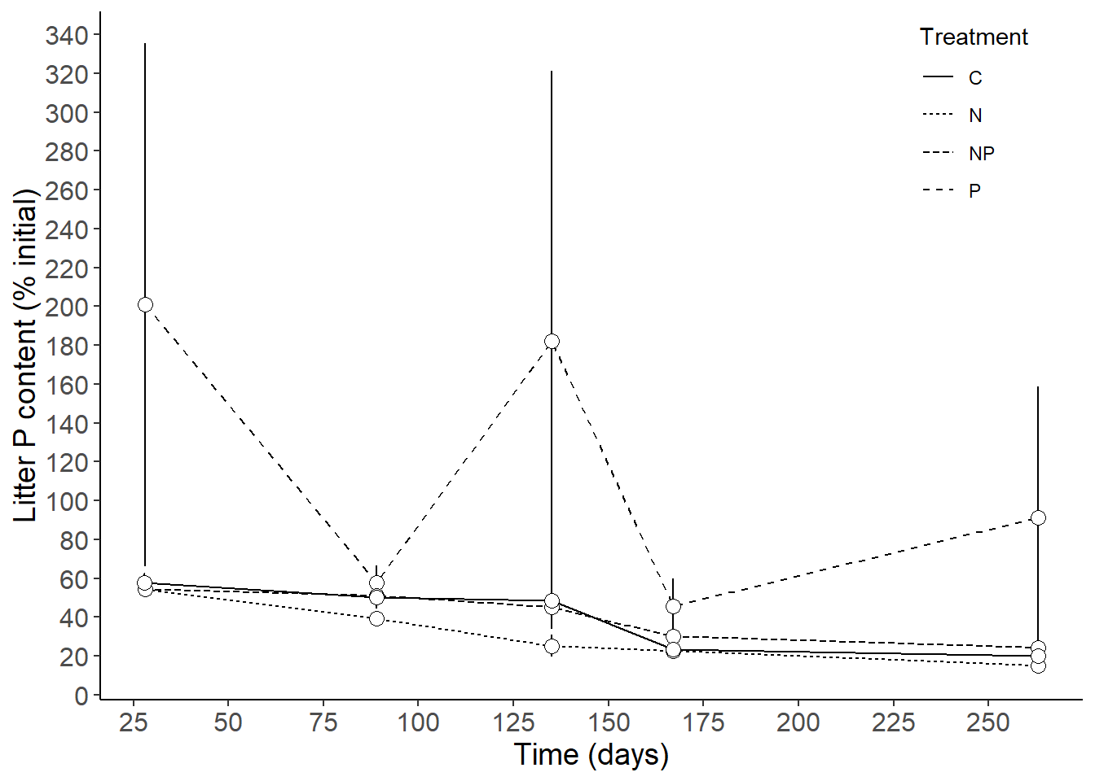

# Figure 6.

# Carbon, nitrogen and phosphorus ratios in leaf litter during a 36-week decomposition study in a long-term forest fertilization experiment in Limón, Costa Rica. ESTE ES EL GRAFICO QUE VA CON LOS ANOVAS DEL CUADRO 2 Y NECESITA LETRAS DEL POSTHOC TEST TUKEY.

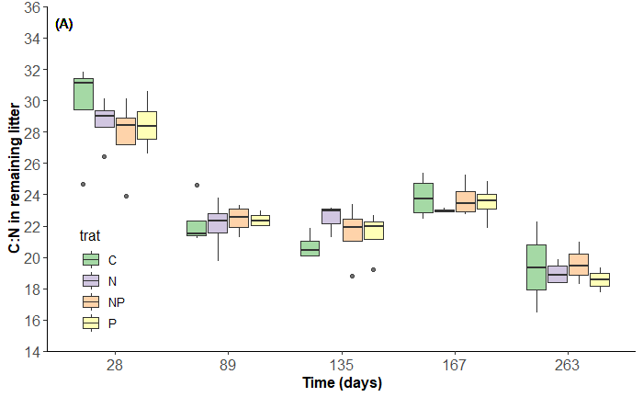

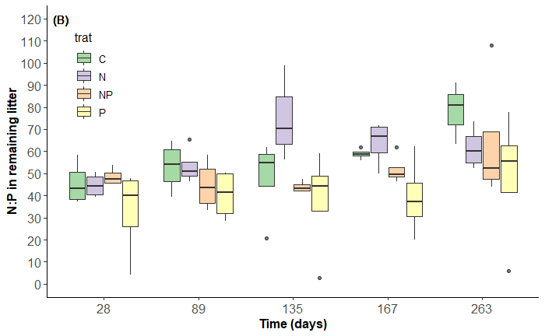

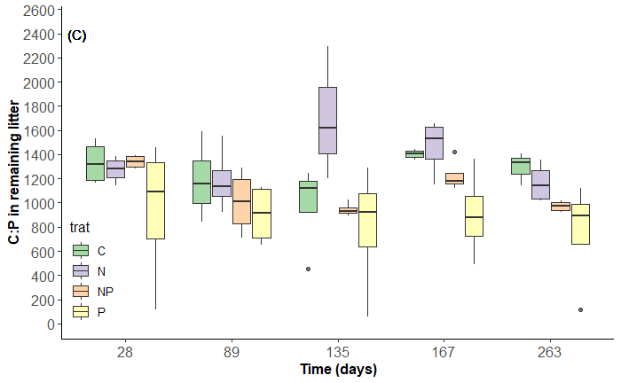

# Leftover figures

## Figure 4.

Nutrient concentration (%) in decaying litterfall (mean ± standard error) over a 36-week period at the EARTH Forest Fertilization Experiment in Guácimo, Limón, Costa Rica.

Do this against mass loss! DO NOT INCLUDE CONCENTRATION GRAPHS IN PAPER. EXCLUIR DATOS DE PARCELA 9 O AL MENOS ANALIZAR SIN ELLOS TAMBIÉN

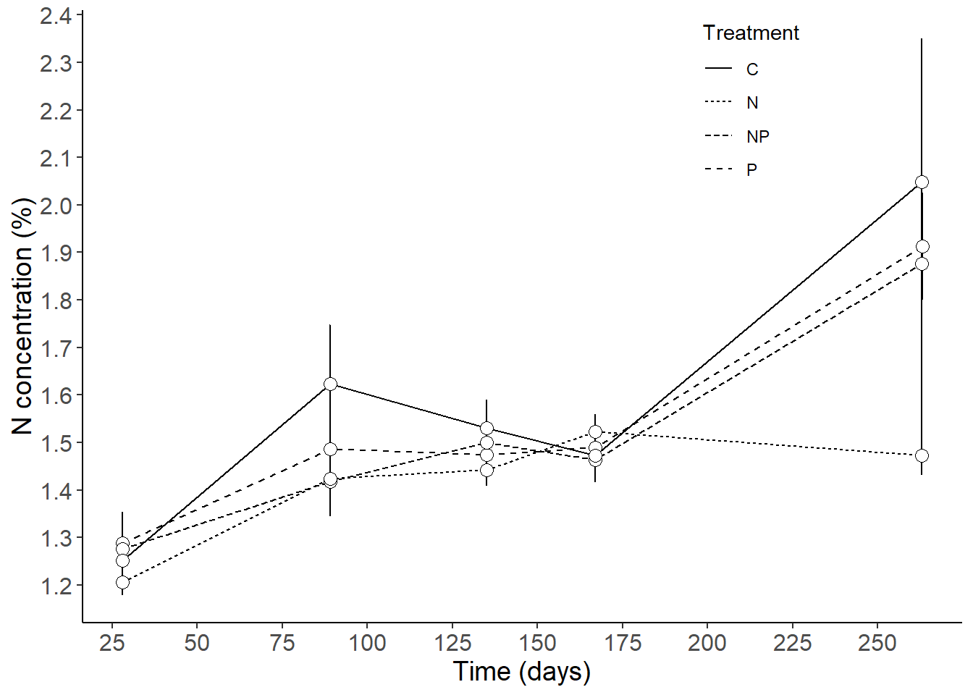

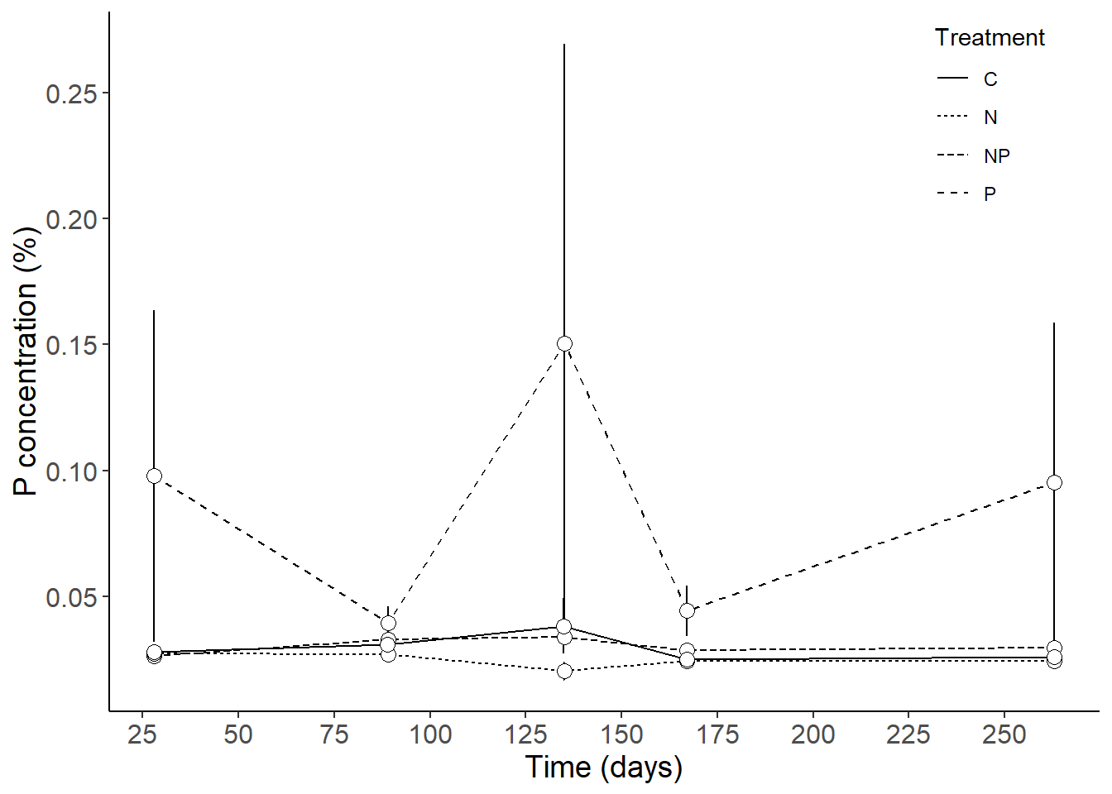

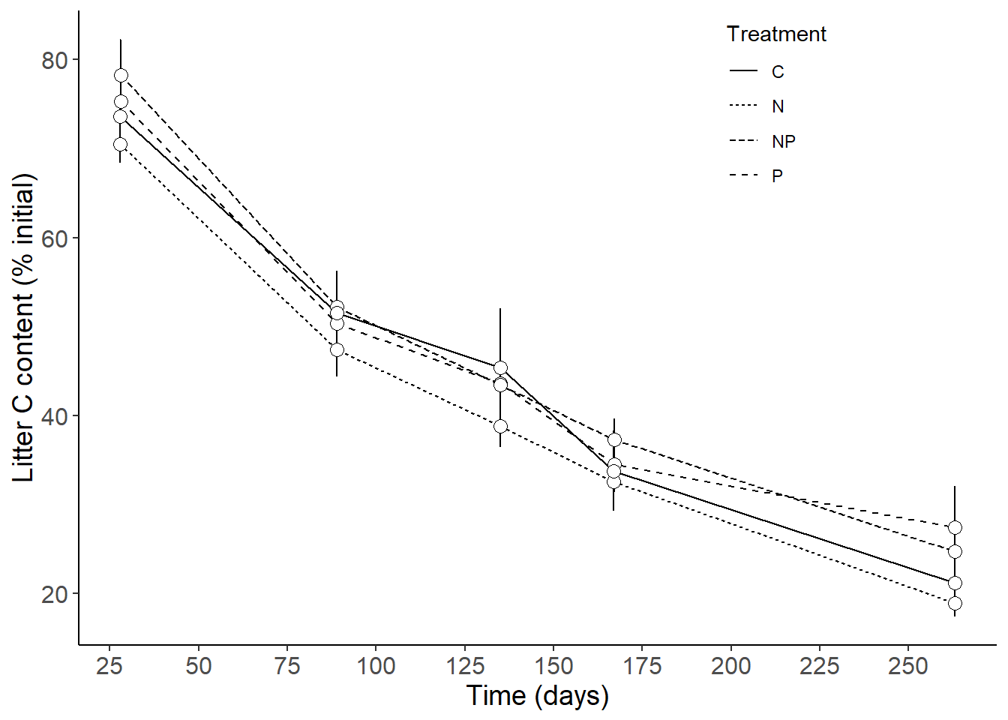

# Extra figures

**Look at Aber and Melillo 1982 they have exact same plots. These graphs represent nutrient immobilised per unit weight loss, a value termed “nitrogen equivalent” by Richards and Norman 1931.**

## Control plots

## +NP

## +P

**+N**

## Control

## +N

## +P

## +NP